

**Navigating Neurological Realms Phase A,**

**Virtual Reality Diagnosis for Early Parkinson's Detection**

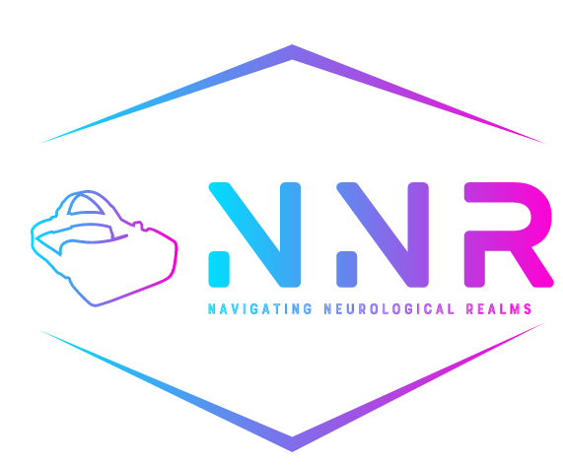

Michael Malka 311446231 [mickael266@gmail.com](mailto:mickael266@gmail.com)

Nir Asulin 305221483 [nir_aso@hotmail.com](mailto:nir_aso@hotmail.com)

**Supervisors**:

Dr. Anat Dahan ( [anatdhn@braude.ac.il](mailto:anatdhn@braude.ac.il))

Dr. Marcela Viviana Karpuj ( [mvkarpuj@braude.ac.il](mailto:mvkarpuj@braude.ac.il) **)**

***Abstract***

Parkinson's disease (PD) is a neurodegenerative disorder that affects millions worldwide, characterized by symptoms such as tremors, bradykinesia, rigidity, and postural instability. Early diagnosis remains a significant challenge due to the subtlety and variability of early-stage symptoms, which can overlap with those of other neurodegenerative diseases. Accurate early detection is crucial for differentiating PD from other conditions to ensure appropriate care plans and timely intervention.

Leveraging advancements in virtual reality (VR) technology, this project proposes a novel approach for early PD detection, aiming to improve diagnostic accuracy and enable timely intervention. The proposed system, dubbed "Navigating Neurological Realms," utilize VR environments to detect subtle motor and cognitive impairments associated with early-stage Parkinson's. By identifying these specific symptoms, the system enhances diagnostic precision, facilitating the initiation of targeted therapies and potential preventative strategies. This project outlines the conceptual framework, technological components, and potential impact of the project, by offering a non-invasive, engaging, and highly sensitive diagnostic tool, "Navigating Neurological Realms" paves the way for more effective diagnostic methods in neurological healthcare. Early and accurate diagnosis can significantly influence the management and treatment of PD, enabling the use of emerging drugs and therapies that slow disease progression, and assisting in planning for future care needs, thereby improving patient outcomes and quality of life.

Code Repository:<https://github.com/mickael266/Navigating-Neurological-Realms>

***Table of Contents***

1. ***Introduction* 4**
   1. **Parkinson Disease……………………………………………. 4**
   2. **Asymmetry in PD Patients…………………………………... 4**
   3. **Our solution…………………………………………………… 5**
2. **Background and Related Work……………………….……………. 5**
   1. **Detection Methods for Parkinson's Disease…………………. 5**
   2. **Methods utilizing Virtual Reality (VR)……………………… 5**
3. **Expected Achievements……………………………………………….. 6**
   1. **Early and Accurate Detection……………………………….... 6**
   2. **Improved Patient Experience…………………………………. 6**
   3. **Data Collection and Analysis………………………………….. 6**
   4. **Additional Applications……………………………………….. 7**
4. **Software Engineering Process…………………………………………. 7**
   1. **Process…………………………………………………………... 7**
   2. **Product………………………………………………………….. 8**

**4.2.1.** **Architecture diagram………………………...……….... 10**

**4.2.2.** **Illustration………………………………………………. 10**

**4.2.3.** **Use Case…………………………………………………. 11**

**4.2.4.** **Flowchart………………………………………………... 12**

**4.2.5.** **CSV file example……………………………………...… 12**

**4.2.6.** **Analyze results………………………………………….. 13**

**4.2.7.** **How Oculus Quest 2 tracks the movements………...… 14**

**5.** **Evaluation plans………………………………………………………... 16**

**5.1.** **Test plan………………………………………………………... 16**

**5.2.** **Tests table………………………………………………………. 17**

**6.** **References……………………………………………………………….. 18**

1. **Introduction** 
   1. **Parkinson’s Disease** (PD), named after James Parkinson, is a progressive, neurodegenerative disease. Neurodegenerative refers to the progressive breakdown of neurons in the brain and nervous system, leading to impairment of cognitive function, motor skills, or both. The brain cells in the brain's substantia nigra gradually deteriorate and lose their function over time. PD is characterised by causing the motor symptoms of tremor, bradykinesia (slowness of movement and speed), and postural instability [1]. PD impacts people in different ways. Not everyone will experience all the symptoms of PD, even if people do, they won’t necessarily experience the symptoms in quite the same order or at the same intensity. Some people experience the changes from the disease's stages progressing over 20 years or more. Others find the disease progresses more quickly. PD is the second-most common neurodegenerative disorder (NDS) in the United States. Most people diagnosed with PD are 60 years or older, however, an estimated 5 to 10 percent of people with PD are diagnosed before the age of 50. Approximately 500,000 Americans are diagnosed with PD but given that many individuals go undiagnosed or are misdiagnosed the actual number is likely much higher. Given the progressive nature of the disabilities associated with PD, the disease affects thousands more wives, husbands, children, and other caregivers. [6]  
       Neuronal loss in the substantia nigra, [9] a critical brain region that produces dopamine, affects many systems of the central nervous system, including movement control, cognitive executive functions, and emotional limbic activity. This neuronal loss causes striatal dopamine deficiency and leads to the formation of intracellular inclusions containing aggregates of α-synuclein. a brain protein involved in nerve cell communication. When excessively accumulated, α-synuclein can form clumps which disrupt normal cellular function and contribute to the progressive loss of neurons. These are neuropathological hallmarks of Parkinson disease [8].
   2. **Asymmetry in PD Patients:** Motor asymmetry is a defining characteristic of Parkinson's disease, typically evident from the disease's onset. Patients often experience more severe symptoms on one side of the body, which can significantly impact their daily functioning and quality of life. This asymmetry is believed to result from uneven degeneration of dopaminergic neurons in the substantia nigra, a key brain area affected by PD. The reasons behind this uneven neuronal loss remain a subject of investigation, with hypotheses including genetic factors, environmental exposures, and variations in neuronal vulnerability. Understanding and monitoring motor asymmetry in PD is crucial for several reasons. Clinically, it assists in the accurate diagnosis and differentiation of PD from other neurological conditions that might present with more symmetrical motor impairments. Furthermore, the degree and progression of asymmetry can inform the tailoring of treatment strategies. Motor symptoms in PD patients remain asymmetric over time, without a significant shift toward symmetry, which highlights the persistent and unilateral nature of PD pathology. This supports the use of motor asymmetry as a diagnostic and prognostic marker in PD [5].
   3. **Our solution** is to create a test, utilizing VR, for the early detection of Parkinson's. The solution will be based on testing motor abilities with an emphasis on diagnosing asymmetry as a possible means of identifying and diagnosing specifically and accurately Parkinson's disease patients at an early stage.
2. ***Background and Related Work***
   1. **Detection Methods for Parkinson's Disease**Currently, two primary methods are employed for the detection of Parkinson's disease (PD).  
      The first method is DaTSCAN, an FDA-approved dopamine transporter imaging technique pivotal in diagnosing Parkinsonian syndromes. By visualizing changes in the dopamine neurotransmitter system characteristic of PD, DaTSCAN, in conjunction with clinical assessments, significantly enhances diagnostic accuracy. This methodology facilitates the differentiation of PD from other conditions that exhibit similar symptoms, thereby improving patient care and treatment planning [2].  
      The second method is the utilization of the Movement Disorder Society-Unified Parkinson’s Disease Rating Scale (MDS-UPDRS). This scale, encompassing a 50-question assessment of both motor and non-motor symptoms associated with Parkinson's, leverages data from the Parkinson’s Progression Markers Initiative to distinguish between long-term symptom changes and short-term fluctuations or measurement inaccuracies. The findings highlight variable reliability across subscales, emphasizing the necessity for more precise monitoring tools in Parkinson's research and treatment [3].
   2. **Methods utilizing Virtual Reality (VR)** are pioneering in advancing the diagnosis and understanding of Parkinson's disease with several innovative approaches. The "Virtual Reality Corridor for FoG-like Symptoms" is an innovative technique used to study Parkinson's disease (PD). In this method, patients with PD are placed in a virtual reality (VR) environment that simulates a corridor. As they navigate through this virtual corridor, it can induce freezing of gait (FoG)-like symptoms. Freezing of gait is a common and debilitating symptom of PD, where a person temporarily feels as if their feet are glued to the ground, making it difficult to move forward.

By using this VR method, researchers can observe and analyze how and when FoG occurs in a controlled setting. This provides valuable insights into the underlying mechanisms and triggers of FoG, contributing to a better understanding of its pathology [7].  
Additionally, DiagnaMed Holdings is developing a cutting-edge tool known as VR/AI Neuro System, which merges virtual reality and artificial intelligence to diagnose Parkinson's disease and other neurological disorders remotely. This system utilizes a VR display equipped with an integrated infrared camera to assess the patient's eye movements, which are crucial for diagnosing neurodegenerative diseases like Parkinson's [12].   
Another notable method is the Virtual Reality Shopping Platform developed by the Cleveland Clinic, which integrates state-of-the-art VR content with an omnidirectional treadmill. This approach quantifies instrumental activities of daily living and aids in identifying early signs of Parkinson's disease by allowing patients to physically navigate a virtual grocery store, thereby providing objective and quantitative biomechanical and cognitive outcomes based on their performance in daily activities [13].

1. ***Expected Achievements***
   1. **Early and Accurate Detection**   
      We are developing a proof of concept for a tool to measure symmetry, which may later aid in diagnosis. We hope that the future integration of a virtual reality (VR) test will significantly improve the early detection of Parkinson's disease. This innovative method is expected to offer high sensitivity and specificity by capturing subtle differences in movement patterns during a virtual swimming task. It is anticipated that the VR test will surpass traditional diagnostic tools like MDS-UPDRS and DaTscan in the future, identifying early changes in motor function that occur before clinical symptoms appear, potentially allowing for earlier healthcare interventions to be developed for diagnosis.
   2. **Improved Patient Experience**   
      Enhancements in diagnostic experiences through our VR application are expected to yield a more immersive and user-friendly interaction. By leveraging VR's immersive qualities, we aim to reduce patient anxiety and improve compliance during diagnostic procedures. Our solution also expands diagnostic access, bridging geographical and mobility barriers through potential telehealth integration, which could be of significant benefit to patients in remote locations or with mobility impairments.
   3. **Data Collection and Analysis**   
      Our VR system will facilitate the collection of intricate movement data during the virtual swimming simulation, aiming to detect asymmetrical patterns indicative of Parkinson's disease. The data, captured in high-fidelity CSV files, will provide a rich dataset for future developing and refining machine learning algorithms. These algorithms will be crucial in analyzing the data to detect asymmetries accurately and to chart the progression of motor function decline over time.
   4. **Additional Applications**   
      This VR testing platform is also poised to pave the way for broader applications within neurological diagnostics and rehabilitation. By establishing reliable markers of disease through movement analysis, the platform may expand to differentiate PD from other neurological conditions with overlapping symptoms. Additionally, this technology holds the potential to facilitate the development of personalized VR-assisted rehabilitation programs, thereby enhancing the quality of life for individuals affected by PD. Ultimately, the platform will be assessed for its efficacy in tracking the effectiveness of new Parkinson's treatments, representing a leap forward in therapeutic assessments and personalized medicine.
2. ***Software Engineering Process***
   1. **Process**

Our project began with a comprehensive examination and research on the neurological condition including its symptoms and the existing solutions. We learned about the people suffering from this condition and their need to fulfill themselves despite the difficulties and limitations it presents. We also searched for existing knowledge regarding how they're currently able to do so through technology that can provide their independence.

We decided is to focus on movement asymmetries in PD and the potential application of VR in medical diagnostics. The motivation for this decision came from an acquaintance who suffers from the disease in its early stages. They reported feeling asymmetry while performing a swimming-type action.

During our research process, we discovered that various physical actions are used for the early diagnosis of Parkinson's disease through the identification of asymmetries, which we detailed in the "background and diagnosis of the disease" stage, but there is not enough extensive knowledge for an unequivocal diagnosis, and even if there is - it does not necessarily take advantage of the inherent possibilities in virtual reality technologies. We found that the knowledge about identifying the disease in its early stages by detecting asymmetry in the action of swimming is still a hypothesis and was not investigated in depth until the beginning of work on this project.

Therefore, we decided to focus on detecting asymmetry during swimming-type actions. Our project is driven by the necessity to create a VR system that can accurately measure and analyze the movement of subjects performing a simulated swimming task. This system is aimed at detecting asymmetries in movement that may be indicative of early stages of PD, in the hope that more innovative studies will use this to develop even more practical and advanced solutions in the future.

We intend to use the Unity engine, coupled with the Oculus Quest 2 VR headset, to deliver a detailed analysis of movement in a simulated swimming environment.

Unity is popular for its user-friendly interface and ability to support a wide range of media assets. Unity also provides extensive tools for VR development and extensive support for Oculus devices and allows to integrate a sophisticated motion tracking system that records participants' movements accurately.

* 1. **Product**

Our project delivers a VR environment, aimed to find asymmetric movements through simulated swimming activities. The system tracks the user's movements during the exercise and records all the movements of the patient into a CSV file, which provides a detailed record of the hand movements in the exercise, after the CSV file will be transferred into an algorithm that will diagnose the data.

The VR environment is built using the Unity game engine. To track the user's hand movements accurately, we utilize the Oculus Hand Tracking feature, which allows for precise tracking of hand positions and gestures. The Oculus Hand Tracking system uses advanced computer vision algorithms and depth sensors to detect and track the user's hands in real-time, providing a natural and intuitive way to interact with the virtual environment.

As the user performs the simulated swimming exercises within the VR environment, the Oculus Hand Tracking system captures the position, orientation, and movement data of their hands. This data is then processed and recorded into a CSV file, providing a comprehensive record of the exercise session. The CSV file includes measurements as a comprehensive set of data. The measurements should include the x, y, z coordinates of each hand (left and right) to track their positions and trajectories during the swimming motions. Additionally, we should record the x_rotation, y_rotation, and z_rotation of each hand to capture the orientation and twist of the hands during the swimming strokes. Optional hand animation data, such as animation curves or keyframes for hand and finger movements, can provide more detailed information about specific hand and finger articulations if needed.

Timing data, including timestamps for each recorded data point, is essential to analyze the timing and synchronization of hand movements between the left and right sides. Event data, such as flags or markers for specific events during the swimming exercise (e.g., stroke start, stroke end, stroke type), can help segment the data and analyze specific phases of the swimming motion. Optionally, we may also consider capturing position and rotation data for other body parts (e.g., arms, shoulders, torso) to provide context and help analyze the overall body coordination during the swimming exercise.

By capturing these comprehensive measurements, we will have detailed information about the hand movements, including their positions, rotations, timings, and relevant events. This data can then be structured into a CSV file, with columns representing each measurement and rows representing the data points at each timestamp or frame of the exercise. This structured data format will make it easier to feed into the algorithm for analysis and diagnosis, allowing us to identify any asymmetries or discrepancies between the left- and right-hand movements, which could potentially be indicative of conditions like Parkinson's disease.

* + 1. **Architecture diagram**

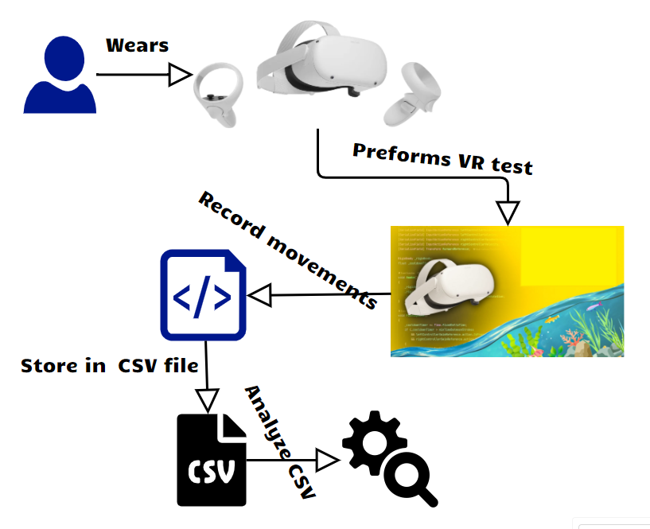

* + 1. **Illustration**



* + 1. **Use Case**

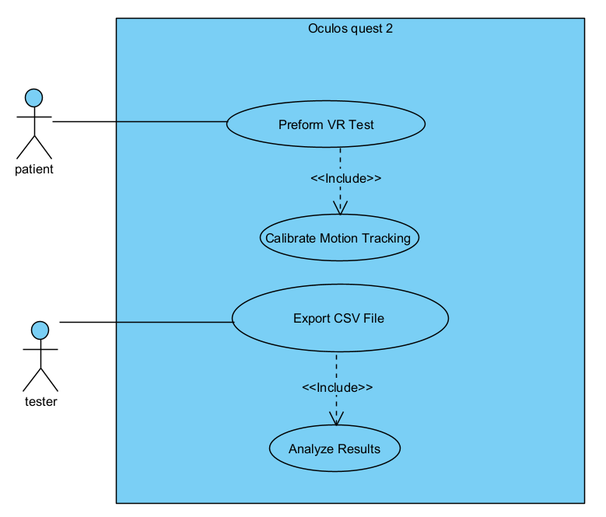

* + 1. 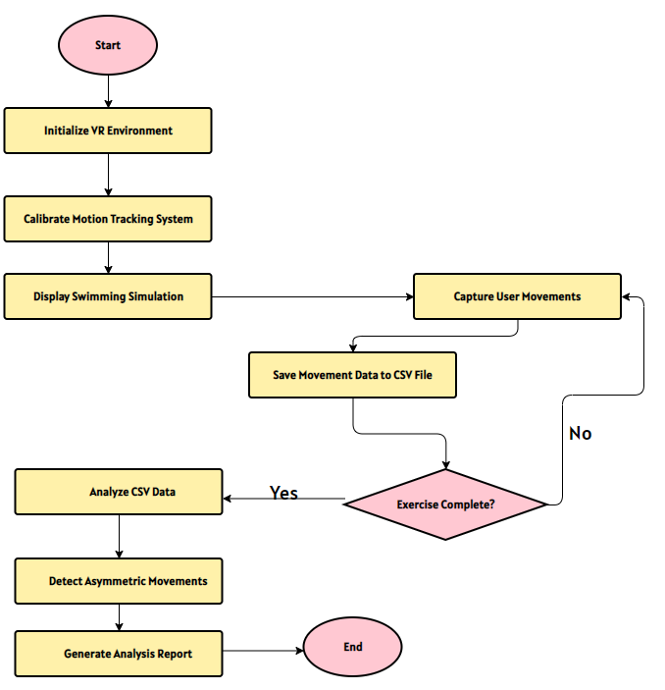**Flowchart**
    2. **CSV file example**

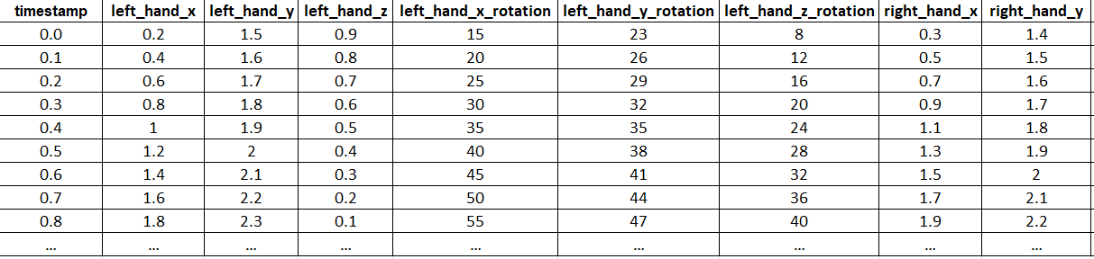

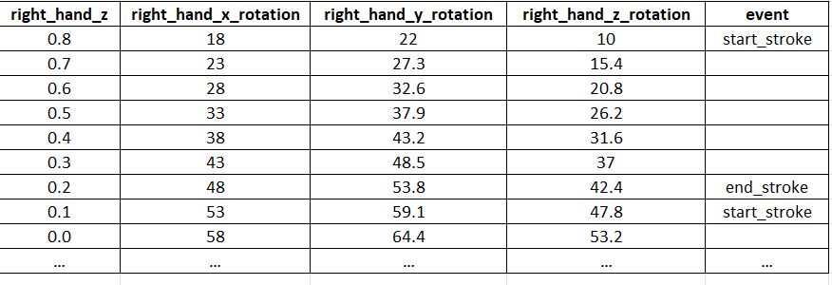

* + 1. **Analyze results,** to determine if a patient exhibits asymmetry in their hand movements, we analyze the differences between the left and right hand measurements for various parameters such as positions, rotations, and timings, as well as the timing differences between the start and end stroke events. The analysis involves calculating the difference between the left and right hand measurements for each data point using the Index of Asymmetry (IA) formula: $IA=|\frac{L-R}{max⁡(L,R)}|​×100$ where L and R are the measurements of the left and right hands, respectively. This calculation is applied to each relevant measurement, such as positions (x, y, z), rotations (x_rotation, y_rotation, z_rotation), for each timestamp.  
       Next, we calculate the timing difference between the start and end stroke events for the left and right hands. This is done by finding the timestamps associated with these events for each hand and calculating the duration of the stroke for each side using the formula: $stroke_duration=timestamp(end_stroke)-timestamp(start_stroke)$.  
       Then we calculate the difference in stroke duration between the left and right hands using the IA formula: ${IA}_{stroke}=|\frac{stroke_duration(left)-stroke_duration(right)}{max⁡(stroke_duration(left),stroke_duration(right)}|×100$.  
       We then calculate the mean Index of Asymmetry across all data points for each measurement type, including the stroke duration difference, by using the formula: $mean_IA=\frac{\sum{IA}}{number of points}$ 
        , which gives the average asymmetry between the left and right hand measurements for each measurement type (position, rotation, timing, and stroke duration).  
       To determine a threshold value for asymmetry, we use the formula: $threshold=α×mean_IA$ 
       (for healthy individuals), where α is a constant factor that defines the acceptable level of asymmetry for healthy individuals. This threshold can be determined based on a dataset of healthy individuals or empirical data. We compare the mean IA for the patient with the determined threshold for each measurement type. $if mean_IA(patient)>threshold$, then the patient is considered to have asymmetry in that measurement.  
       Finally, we combine the results for different measurements. If the patient is flagged as having asymmetry in multiple measurements (positions, rotations, timings, and stroke duration), it increases the likelihood of asymmetric hand movements, which could be indicative of Parkinson's disease. By incorporating the stroke duration difference calculation and including it in the analysis, we can potentially identify asymmetries in the timing and coordination of hand movements during specific strokes, which could be an important indicator of Parkinson's disease [4].
    2. **How Oculus** **Quest 2** **tracks the movements** the Oculus Quest 2 employs a sophisticated array of sensors to detect and track the user's movements with high accuracy and low latency. At the core of its motion tracking capabilities lies the Inertial Measurement Unit (IMU), which integrates accelerometers and gyroscopes. These sensors measure the acceleration and rotational movement of the headset, providing essential data for calculating its position and orientation in 3D space.

Complementing the IMU is the Quest 2's advanced inside-out tracking system, eliminating the need for external base stations or sensors. This system relies on four ultra-wide-angle monochrome cameras strategically placed on the front and sides of the headset. These cameras capture images of the user's surroundings and track the infrared (IR) LED patterns on the controllers and the headset itself.

The Quest 2 further enhances its tracking capabilities using advanced computer vision algorithms and Simultaneous Localization and Mapping (SLAM) techniques. These algorithms scan and map the user's physical environment, allowing the headset to localize itself and the controllers within the mapped space, enabling accurate positional tracking without the need for external sensors. Additionally, a depth sensor captures depth information about the user's surroundings, creating a more accurate and detailed environmental map to further enhance the tracking capabilities of the inside-out system.

One of the standout features of the Quest 2 is its hand tracking capabilities. Users can interact with virtual objects using just their hands, without the need for controllers. This is achieved through the monochrome cameras and advanced machine learning algorithms that can detect and track the user's hand movements in real-time.

Like other Oculus headsets, the Quest 2 also features a proximity sensor that detects when the headset is being worn or removed from the user's face. This information is used to adjust the display and tracking accordingly, ensuring a seamless transition between the virtual and real-world environments.

By combining data from the IMU, inside-out tracking system, depth sensor, hand tracking capabilities, and proximity sensor, the Oculus Quest 2 can provide highly accurate and responsive motion tracking. This advanced tracking technology enables users to fully immerse themselves in virtual environments and interact with virtual objects in a natural and intuitive manner, delivering an unparalleled virtual reality experience.

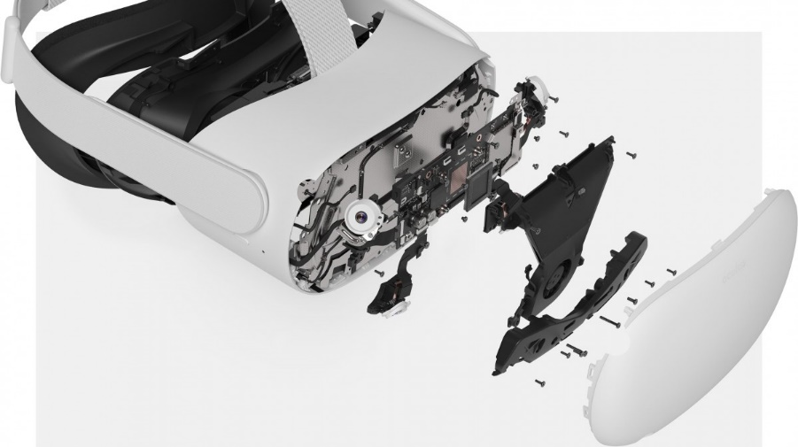

* + 1. **How Unity accesses the movement data recorded by the Oculus Quest 2** You can access and integrate the movement data through the Oculus Integration package and Unity's built-in XR (Cross-Platform Virtual Reality) Input Subsystem. The Oculus Integration package [10], provided by Unity, supports the Quest 2 and its advanced inside-out tracking system. Developers can leverage the same classes and methods from the package, such as OVRCameraRig and OVRInput, to access the position, rotation, and other tracking data for the Quest 2 headset and controllers. The package automatically handles the differences in tracking methods between the Quest 2 and other Oculus headsets, abstracting away the complexities of the inside-out tracking system. Additionally, Unity's XR Input Subsystem [11] offers compatibility with the Quest 2, enabling developers to retrieve its movement data using consistent APIs and methods. This subsystem provides a unified interface for accessing input data from various XR devices, including the Quest 2, abstracting away the specifics of the inside-out tracking system. Developers can utilize the XR Input Subsystem to access the position, rotation, and other tracking data for the Quest 2 headset and controllers. One of the standout features of the Quest 2 is its hand tracking capabilities, allowing users to interact with virtual objects using just their hands, without the need for controllers. Unity's Oculus Integration package and the XR Input Subsystem provide APIs and methods to access the hand tracking data from the Quest 2. The Quest 2's inside-out tracking system utilizes environment mapping and spatial awareness to track the headset and controllers within the user's physical surroundings. Unity provides access to this environmental data through the Oculus Integration package and the XR Input Subsystem, enabling developers to create virtual representations of the user's physical environment. This allows for features like occlusion, spatial anchoring, and scene understanding, further enhancing the immersive VR experience. Moreover, developers can create custom scripts and MonoBehaviours in Unity to access and process the movement data from the Quest 2. These scripts can utilize the classes, methods, and APIs provided by the Oculus Integration package and the XR Input Subsystem to retrieve the tracking data, including headset position, rotation, controller input, hand tracking, and environmental data. By leveraging these tools and capabilities, Unity developers can seamlessly integrate the Oculus Quest 2's movement data into their VR applications, enabling the creation of highly interactive and immersive VR experiences tailored for the Quest 2 platform.

1. ***Evaluation plans***

As part of software development, it is necessary to evaluate the system built and to reach a high level of performance. We will act according to the following plan:

1. Test table will be built for the functionality of the system, and we will make sure that the system works according to the plan.
2. Initially we will perform these tests (as representatives of normal individuals that can easily perform all tasks) at all stages of software development.
3. To maximize the quality of the tests, we will analyze the system by a ping-pong player group of PD patients at various stages.
4. The system will also be tested on healthy people.
   1. **Test plan** as we noted in the evaluation plan, we need to build an orderly testing plan that encompasses all the functional and non-functional operations in the system.

The testing program is designed to detect weaknesses, and problematic processes and is designed to verify the accuracy of the various actions contained in the system.

As mentioned in the article, the VR works with several sensors, and we need to make sure that they work as required and that the information extracted from them enables us to perform the appropriate analyses to obtain the desired results. We anticipate that this is the main difficulty in developing the software.

We built the test plan with the help of the Use case diagram which contains all the main scenarios in each complex process in the system which we must verify are correct.

* 1. **Tests table**

|  |  |  |
| --- | --- | --- |
| # | Test case | Expected result |
| 1 | The system opens the VR test | The VR test interface is opened and shown on the screen |
| 2 | Calibrate motion tracking | The system automation opens and starts the calibration process |
| 3 | The user completes the test, and the data is saved to a CSV file. | The data is saved successfully. |
| 4 | The tester imports the CSV file. | The data is imported successfully. |
| 5 | The user performs an asymmetrical movement | The asymmetry will be reflected in the results file |
| 6 | The user performs a slow motion | The slow motion will be reflected in the results file |
| 7 | The user stops the test before it is finished | No CSV result file will be saved |
| 8 | Compare (symmetry) result between ping-pong (diagnosed with Parkinson's) and healthy groups | There is information needed to provide analysis |
| 9 | Compare (symmetry) result between ping-pong (diagnosed with Parkinson's) and patients with other neurodegenerative diseases (such as Alzheimer's, Huntington’s and Prion Diseases) | To be able to identify Parkinson's patients even though there are similar problems to patients with these diseases in their early stages |
| 10 | Compare (symmetry) result between Parkinson's patients at different stages of the disease | Possibility to see if it is possible to predict the progression of the disease |

***6.******References:***

[1] Capriotti, T., & Terzakis, K. (2016). Parkinson disease. *Home healthcare now*, *34*(6),   
300-307   
<https://pubmed.ncbi.nlm.nih.gov/27243427/>

[2] de la Fuente-Fernández, R. (2012). Role of DaTSCAN and clinical diagnosis in Parkinson disease. *Neurology*, *78*(10), 696-701.‏  
<https://www.neurology.org/doi/abs/10.1212/WNL.0b013e318248e520>

[3] Evers, L. J., Krijthe, J. H., Meinders, M. J., Bloem, B. R., & Heskes, T. M. (2019). Measuring Parkinson's disease over time: the real‐world within‐subject reliability of the MDS‐UPDRS. *Movement Disorders*, *34*(10), 1480-1487.

<https://movementdisorders.onlinelibrary.wiley.com/doi/full/10.1002/mds.27790>

[4] Kuhtz-Buschbeck, J. P., Brockmann, K., Gilster, R., Koch, A., & Stolze, H. (2008). Asymmetry of arm-swing not related to handedness. *Gait & posture*, *27*(3), 447-454.‏

<https://www.sciencedirect.com/science/article/pii/S0966636207001361>

[5] Miller-Patterson, C., Buesa, R., McLaughlin, N., Jones, R., Akbar, U., & Friedman, J. H. (2018). Motor asymmetry over time in Parkinson’s disease. *Journal of the neurological sciences*, *393*, 14-17.‏

<https://www.sciencedirect.com/science/article/pii/S0022510X18303125>

[6] National Institute of Neurological Disorders, & Stroke (US). (2004). *Parkinson's disease: Challenges, progress, and promise*. National Institute of Neurological Disorders and Stroke, National Institutes of Health  
<https://www.ninds.nih.gov/current-research/focus-disorders/parkinsons-disease-research/parkinsons-disease-challenges-progress-and-promise>

[7] Pereira, C. R., Pereira, D. R., Weber, S. A., Hook, C., De Albuquerque, V. H. C., & Papa, J. P. (2019). A survey on computer-assisted Parkinson's disease diagnosis. *Artificial intelligence in medicine*, *95*, 48-63.‏

<https://www.sciencedirect.com/science/article/pii/S0933365717305663>

[8] Poewe, W., Seppi, K., Tanner, C. M., Halliday, G. M., Brundin, P., Volkmann, J., ... & Lang, A. E. (2017). Parkinson disease (Primer). *Nature Reviews: Disease Primers*, *3*(1).‏  
<https://sci-hub.se/https://www.nature.com/articles/nrdp201713>

[9] Sonne, J., Reddy, V., & Beato, M. R. (2022). Neuroanatomy, substantia nigra. In *StatPearls [Internet]*. StatPearls Publishing.‏  
<https://www.ncbi.nlm.nih.gov/books/NBK536995/>

[10] **oculus integration package documentation** <https://developer.oculus.com/documentation/unity/>

[11] **Unity XR documentation**

<https://docs.unity3d.com/ScriptReference/XR.CommonUsages.html>

[12] "Virtual Reality System May Help Diagnose Parkinson's." Parkinson's News Today, 2024,  
<https://parkinsonsnewstoday.com/news/virtual-reality-system-may-help-diagnose-parkinsons/>

[13] Using Virtual Reality to Identify Early Signs of Parkinson Disease: Jay Alberts." NeurologyLive   
<https://www.neurologylive.com/view/using-virtual-reality-identify-early-signs-parkinson-disease-jay-alberts>